|  |
| --- |
| **Consulting** |
| WMS Troubleshooting |
|  |

 



Content

1 Access is denied when installing a WMS Service 3

2 This Access control list is not in canonical form and therefore cannot be modified. 5

## Access is denied when installing a WMS Service

It is common that when we want to install WMS synchronization services we get the following error:

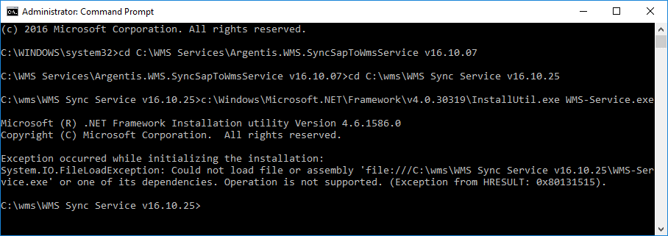

This is mainly because the files inside the installation folder are blocked. The solution is very simple:

1. Go to the folder where we have unzipped all the files to install the service:

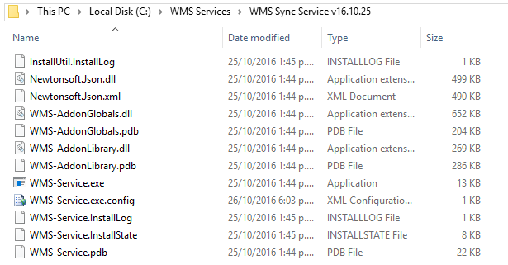

1. To each of the above-mentioned files, right click and access to the properties:

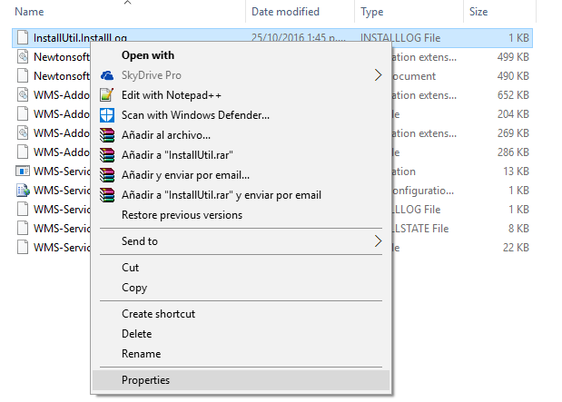

1. In the properties we will check the option unlock:

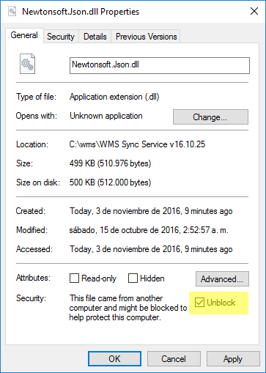

1. Finally, we click on “apply” to save the changes and perform the same procedure for all the files.

**NOTE:** If any of the files do not have the Unblock option, then the file is already unblocked.

## This Access control list is not in canonical form and therefore cannot be modified.

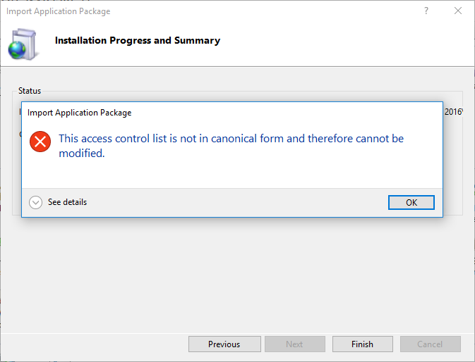

After we install the web application, it is very common that the application shows us the error mentioned above.

To solve this problem, we must follow the following steps:

1. must edit the permissions of the application:

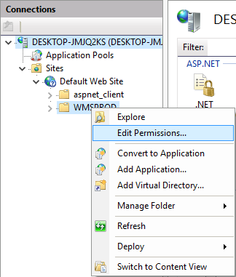

1. In the next screenshot is shown that when we access to the Security tab, automatically a message will pop up, we must click on OK.

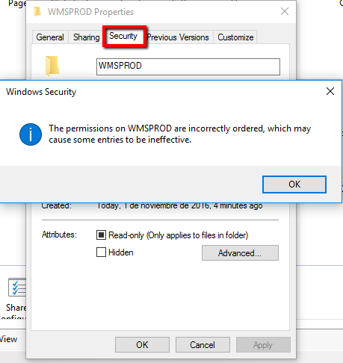

1. The next step is to edit User Groups or Names:

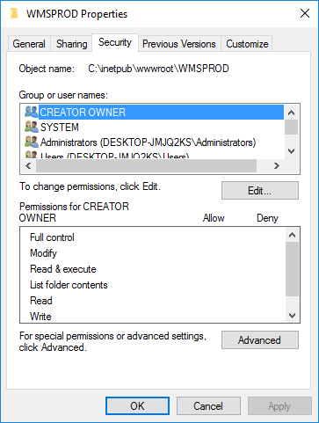

1. After clicking on Edit, we will find the following message:

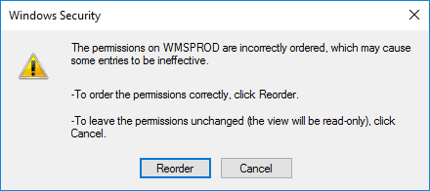

We click on Reorder.

1. We continue applying the changes:

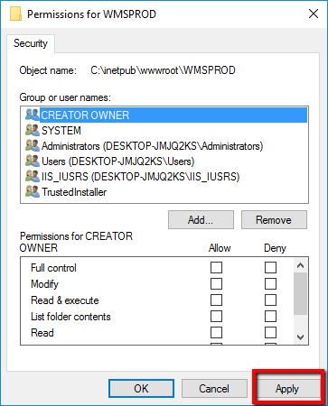

1. To finish, we must convert our folder to application:

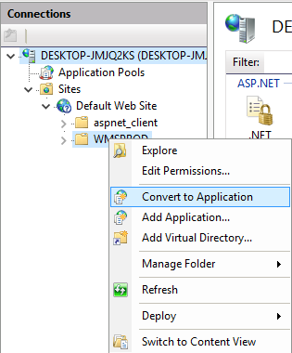

1. We click on OK to the following screen to finish:

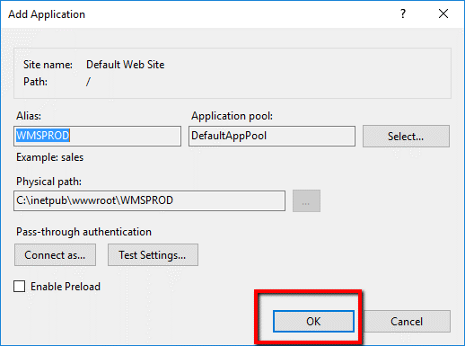

We will see that our application is already online.

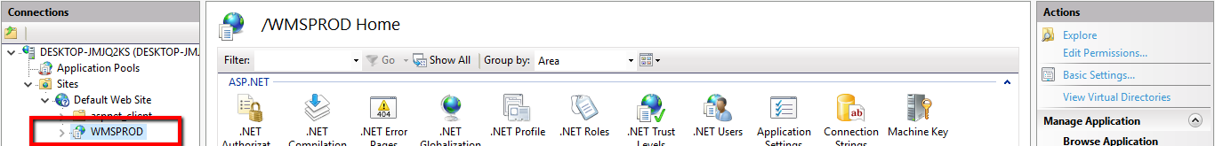

1. Repeat this step for the installation of any web application with this type of problem.

# 